Logic Design Final Exam (SEMI)
2022. 05. 30.
10 points/problem if not specified.

1. Simplify the logic expression.
(A’ + B) (CD + E’) + (A’ + B) (CD + E’)’

2. For F’(A, B, C, D) = Σ m(0, 1, 2, 6, 7, 13, 15)
(a) Find the minterm expression using K-map.
(b) Modify your expression to prevent any hazard(s)

3. Find a minimum SOP solution using the QM method.
f(a, b, c, d) = Σ m(2, 3, 4, 7, 9, 11, 12, 13, 14) + Σ d(1, 10, 15)

4. Convert the following circuit to all NOR gates. Inverter(s) are allowed.
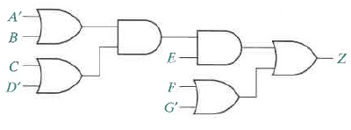
5. Realize an 8-to-1 MUX with two 4-to-1 MUXs and two three-state-buffers (NO 2-to-1 MUX). Do not specify three control (select) lines.

6. Derive the characteristic and excitation equations for JK and T type flip-flops then convert a JK flip-flop to a T flip-flop.

7. Design an even counter (0, 2, 4, …, 10, 0) with SR type flip-flops. (20 points)

8. Design a Mealey type sequence detector for finding ‘001” with JK type flip-flops. (20 points)

Solution part

- A’ + B
- Skip
- Skip
- Skip

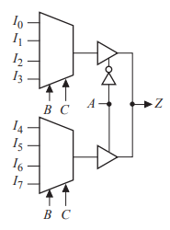
- Skip
- Skip
- skip

